MKTG 4106 and MKTG 5210
Clayton State University
Marketing Final Project Overview

Introduction:
The purpose of the Marketing Final Project is to demonstrate your understanding of internet marketing and applying your knowledge in a real-world setting. Utilizing SWOT (Strengths, Weaknesses, Opportunities and Threats) you will provide an understanding of the firm, identifying strategic issues and your recommendations for alternative plans of actions.
The Instructor will follow the guidelines found in Oral Presentation and Written Skills Rubrics for grading (see below).
You will need to research a publicly traded, Fortune 500 company (instructor approval required). You will need to apply sound business strategy concepts to your evaluations and you will need to convey this information with quality writing and communication skills. This is an important research paper so please prepare accordingly.
Strategic Recommendations:
You are to recommend a corporate-level strategic decisions (e.g., terms/strategies, etc. covered in this course). This is the most important part of the paper and thus will be expected to support your recommendation. Be sure to incorporate terms/concepts, etc. that we have covered in this course to explain your analysis recommendation.
Due Dates:
June 3 – Company Project Form
July 22 - Presentation Date – Individual oral presentation with written report.
Due Date for individual/in pairs written reports and in-class presentations are July 22 after Exam 4. Forms, the paper and presentation are due at the beginning of class on the dates assigned. If duplicate companies are submitted, company choices will be determined on first submission or if both are submitted at the same time, then decision will be made by random draw.

Strategy Project - Written Outline
The following format basics are standard guidelines for the format of the research paper: The document should be double spaced in 12 point Times New Roman font. The header should contain the company name and the page number. The paper is expected to be three pages in length including the title page.
Sections: The sections of the paper need to be clearly labeled. All of the following sections must be included.
- Title Page: Consists of a single cover page and should include the following: student’s name, course name and section, date submitted, date due, and company name analysed.
- Company Overview: Provides a description regarding the business/industry the company is participating in, and a brief history of the firm. Include such items as number of employees, gross sales, market share, etc. Paint an overall picture of the firm for those who may know nothing about the company.
- Firm’s Current Situation to consider (not all inclusive)
  - SWOT Analysis Conducted
  - Brand
  - Internet Marketing Strategy
  - Value Chain
  - Business Model
  - Customer Acquisition Techniques
  - Web Performance/Effective Website
  - Social Media Utilization
  - Competitive Strategies
  - Customer Service
  - Customer Retention
- Strategic Recommendations:
  - WHY, WHY, WHY: Explain your rationale behind all decisions. Why did you select this strategy? Be sure to have your recommendations address the many problems/weaknesses you addressed earlier in the presentation (don’t just leave problems in place – attempt to correct them) AND take advantage of the opportunities and strengths of your firm.
5. References: The reference section and in-text citation method will follow APA format (for information on this style and how to handle all references/citations, please see http://owl.english.purdue.edu/owl/resource/560/01/. ) You are to properly cite throughout the work any and all information NOT found in the text.
Assignments should be submitted in Word format (.doc) to the appropriate KSU D2L Assignment by the respective deadline. All submissions must be in the students’ own words (no copying and pasting). Plagiarism will not be tolerated.
SWOT: What to Look for in Identifying a
Company’s Strength, Weaknesses,
Opportunities and Threats

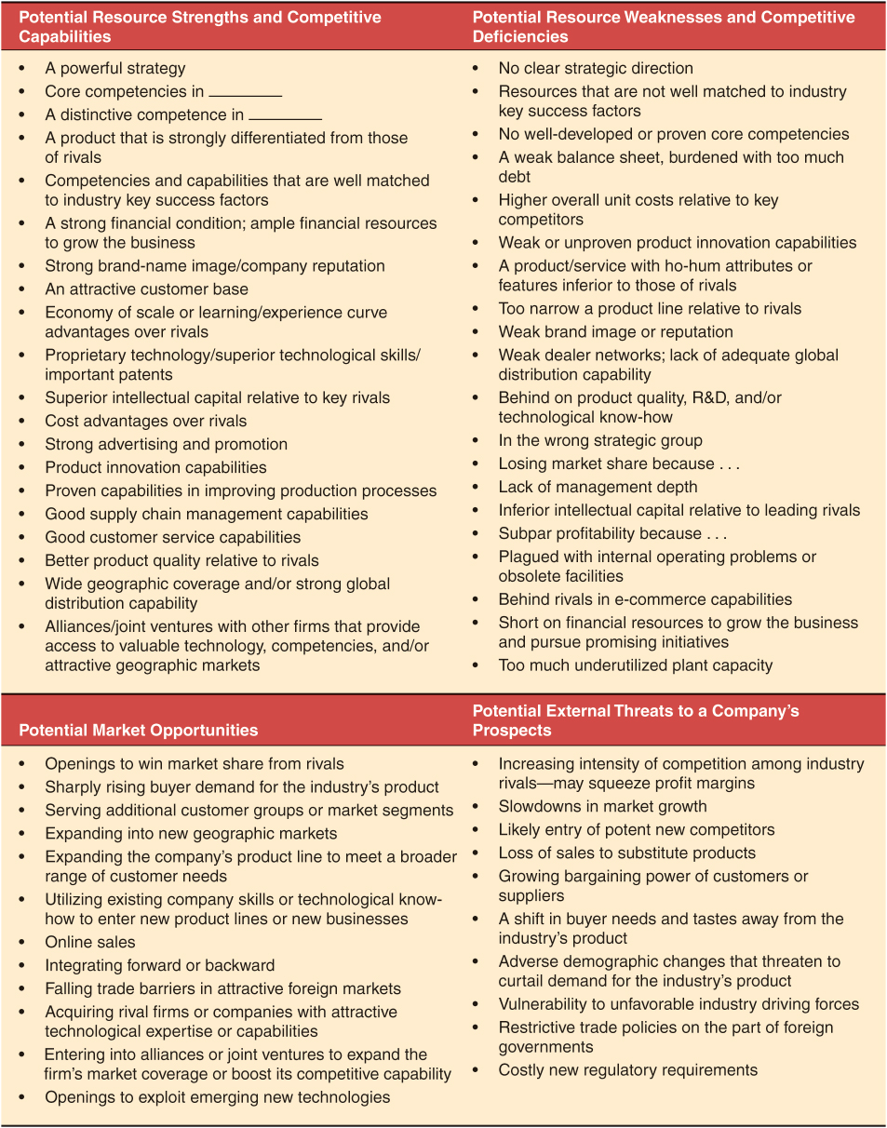
Provided by Dr. Anne Gottfried, University of Southern Mississippi

Grading Rubric Provided by Dr. Anne Gottfried, University of Southern Mississippi

Performance  Area | Excellent  3 | Competent  2 | Poor  1 | Item  Score | Overall  Score
Oral Presentation Assessment
Delivery Style | Speaker uses grammatically correct and appropriate language. Smooth, effective delivery. | Speaker generally uses correct and appropriate language. Some hesitation in delivery. | Speaker appears unpracticed. Unnecessary pauses, filler words. Incorrect or inappropriate language.
Speaking Skills | Good voice control, eye contact, and physical demeanor. | Adequate voice control, eye contact, and physical demeanor. | Problems with voice control, eye contact, or posture.
Structure/  Organization | Presentation is clear, logical, and organized. Issues clearly identified, topic thoroughly discussed, conclusion offered. | Presentation is generally clear and well organized. A few minor points may be confusing. Some issues identified, adequate discussion, some conclusion offered. | Presentation is difficult for listener to follow. Some arguments are not clear. No clear identification of issues, lack of thorough discussion, and no conclusion offered.
Visuals | Visuals help the flow of the presentation, are easy to read, and informative, and are prepared in a professional manner. | Visuals contribute to the quality of the presentation. Some material not supported by visuals. | Visuals are poorly prepared or used inappropriately.
Content  Knowledge | Students fully understand the material being applied and know how to use the material appropriately in the context of the assignment. | Students partially understand the material being applied and may use some material appropriately, but do not have a full grasp of the material. | Students do not understand the material being applied and do not use material appropriately in the context of the assignment.
 |  |  | Oral Presentation Assessment
Performance  Area | Excellent  5 | Competent  3 | Poor  1 | Item  Score | Overall  Score
Written Communication Assessment
Structure/  Organization | Organized from beginning to end; introductory and conclusion paragraphs included; clear focus, fluent, cohesive. | Organized but may have lapses; transitions evident; usually has clear focus. | Organizational structure inconsistent; poor transitions; focus unclear
Word Selection and Sentence Structure | Excellent word selection and use; sentence structure logical and well-ordered | Adequate word selection and use; sentence structure adequately logical | Serious and persistent errors in word selection and use; sentence structure poorly ordered and/or confusing.
Spelling, Punctuation, and Capitalization | Excellent spelling, punctuation and capitalization; carefully edited. | Adequate spelling, punctuation, and capitalization; needs some editing. | Serious errors in spelling, punctuation, and capitalization; needs extensive editing.
Content | Assigned topic is covered in depth; appropriate issues are fully identified; assignment fully completed. | Coverage of topic is adequate, most issues are identified; generally meets assignment requirements. | Inadequate coverage of topic, minimal identification of issues; does not meet assignment requirements.
Research | Excellent set of relevant references appropriately applied in analysis. | Adequate set of references, some application in analysis. | No or inappropriate use of references.
 |  |  | Written Communication Assessment

